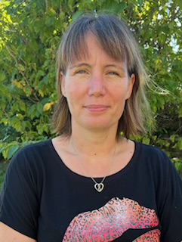 | Name: | Mrs Mary Clothier
 | Designation: | Co-opted Governor - Chair
I am privileged to have taken on the role of Chair of Governors in 2024, following a period of four years as a Co-opted Governor, and to be working with such a professional and dedicated team of staff and governors.
For the last 17 years I have lived on the outskirts of Bridgwater with my mum, husband and two boys. I currently work from home as an Executive Assistant for my husband’s IT company. This allows me to spend more time with my family, volunteering and enjoying my favourite hobbies; travelling, gardening and running. Previously to my current job, I was a Somerset Headteacher working at various Church Primary Schools. Therefore, I have a vast amount of experience in education and have been fortunate during my teaching career to have taught from Year 1 to Year 6, before becoming a Headteacher.
As the Chair of Governors, alongside the other skilled and experienced governors, I have the pleasure to work with the Headteacher and the committed staff to support the strategic direction and ethos, shaping the lives of St. Mary’s pupils in a safe, happy and stimulating environment.

​​​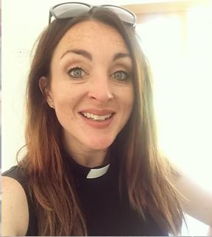 | Name: | Rev Suse Osmond
 | Designation: | Ex-Officio Governor – Vice Chair
 | I joined the governors of St Mary’s in the Autumn Term 2018, whilst working in the parish as Curate at St Mary’s Church. In October 2021 I was delighted to be licensed as Vicar of St Mary’s and continue my journey with the school. I feel privileged to regularly lead Collective worship and have a particular interest is supporting the ethos and values of the school investing into a nurturing and thriving community where both staff and children feel valued and enabled to reach their full potential. It is a real joy to be a part of the school’s governing body.

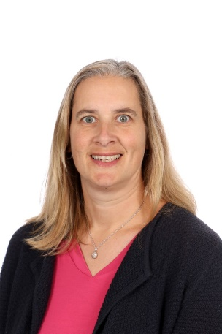 | Name: | Mrs Morwenna Dunstan
 | Designation: | Headteacher – Staff Governor
 | I am the Headteacher here at St Mary’s School and I think that I probably have one of the best jobs in the world. I have been a teacher for over 20 years, and I still love coming to work every day. It is a joy to work with the children at our school; they make me smile every day, and working in a school there is always something new to learn. I was a governor at my last school, where I was also Headteacher, and I fully appreciate the commitment and hard work that governors put into their role. Governors from different backgrounds and different experiences enrich the leadership of our school. When I am not at work, my husband and 2 boys keep me busy with all their sporting interests, and I have recently taken up running and ran the Bath Half Marathon, to raise money for Parkinson’s UK.

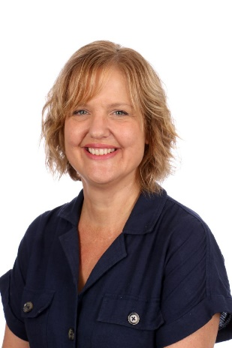 | Name: | Mrs Caroline Layton
 | Designation: | co – opted Governor
St Mary’s School is a very special place for me; I love the family feel and nurturing environment, which is so important for children and adults to thrive. I have been working here for more than 30 years, and it is always so lovely to see parents, who I once taught, bringing their own children to St Mary’s. For the past 6 years I have been Deputy Head. I still, however, teach one day a week, which I enjoy, as spending time with the children and seeing them flourish is why I chose to become a teacher.
My family is very important to me and when I am not working, I love spending time with them and my three cats. In my spare time, I also enjoy going to the theatre and I love to relax with a good book.

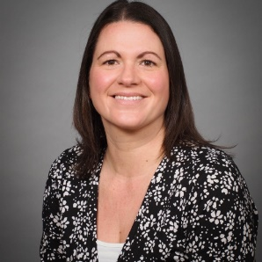 | Name: | Miss Kara Stevens
 | Designation: | Staff Governor
I have worked as a TA at St Mary's since January 2019.
I love spending time with the children, helping them flourish and watching them grow and learn. I adore my job, there is no better feeling than seeing the children I work with grow in confidence, both socially/emotionally and academically. In addition, I love working with the wonderful staff of St Mary's. I have made many new friends over the years. I am excited to be joining the board of governors too.

I have lived in Bridgwater since 2010, having moved here when I met my partner.
We had our daughter, Maddy in 2012.
I was made redundant from my insurance job in 2016, so I took a year out of work to settle our daughter into school and return to college to gain my qualifications to work as a TA. I love reading, gardening, travelling, walking and spending quality time with my family.

​​​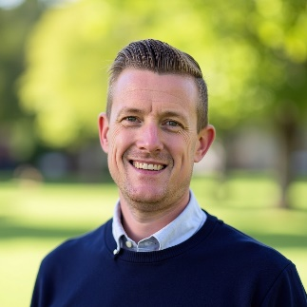 | Name: | Mr David Ballentine
 | Designation: | Parent Governor
 | I have grown up in Bridgwater and have two children that attend St Mary’s. I am a qualified Financial Adviser with over 13 years of industry experience. I am a director of two local family businesses in Financial Advice and Estate Planning. I’m passionate about my local community and am an active member of the Bridgwater Chamber of Commerce. I am looking forward to supporting an already fantastic school. I’m interested in efficiency and sustainability within the school. In my spare time that I’m not with my family, you will find me on the golf course.

 | Name: | Mrs Emma Cocks
 | Designation: | Parent Governor

​​​ | Name: | Mr Steve Cross
 | Designation: | Foundation Governor
 | I am Bridgwater born, bred & educated, but do not hold that against me! I am now retired after a stint in the Merchant Navy direct from school & then a long career in customer service/sales & export shipping. My passions are music, the sixties mainly, and going to concerts, supporting the best football team, (they play in all red, but do NOT play in Manchester!) I love foreign travel and have been very lucky to have visited so many wonderful places, the Greek islands being a particular favourite. My link to the school is that my son attended back in the day, and as time has gone by, my granddaughter now is a pupil there. My grandson is due to start at Little Oaks in September… I still live just a short walk away and I now have the time and would like to give something back.

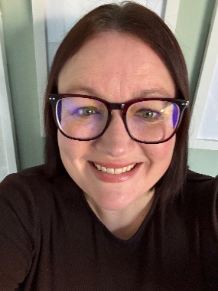 | Name: | Michelle Roberts
 | Designation: | Co-opted Governor
 | I live in Bridgwater with my Wife and Daughter, who is in Year 4 (soon to be Year 5) of St Mary’s. I am a senior level people professional, currently working as Head of People and Learning for a technology company. I hope to bring my specialism in organisational development and design to my role as Governor, helping it to be not only the best school it can be but also the best employer. I am organised, personable and passionate about wellbeing; skills I hope will enable me to fully support St Mary’s. In what little free time I have (as a working Mum) I like to run so you will most likely find me running around the local area complaining about how hilly it is!

 | Name: | Kirsty Nunn
 | Designation: | Co-opted Governor
 | I am delighted to serve as a Parent Governor at St Mary's Primary School. As a parent of two boys, Freddie and Monty, I understand first-hand the importance of creating a school environment where every child feels valued, supported and inspired to achieve their potential. Professionally, I am Head of Computer Science at Millfield School, where I also contribute to whole-school initiatives focused on teaching, learning, and coaching. My background in education has given me experience in curriculum development, staff development, SEN support and creating opportunities that help young people flourish both academically and personally. I am passionate about helping children develop confidence, curiosity and a love of learning. I believe schools play a vital role not only in academic achievement but also in nurturing character, resilience and wellbeing.

 | Name: | Scott Mason
 | Designation: | Co-opted Governor
I have lived on the school housing estate my entire life, and today, I am proud to be raising my own family here. My commitment to our town isn’t just personal; it is also professional. Working locally in local government, I have a firsthand understanding of how our public services operate and a deep appreciation for the facilities that keep our community thriving.
I am proud to be in a school governor position because I care passionately about the future of Bridgwater. For me, "bettering our future" means investing heavily in the next generation, and that starts with an exceptional education sector. I want to ensure our local schools have the support, leadership and resources they need to help every child succeed.
As a dedicated family man and a proud local, I am fully committed to bringing my professional experience, local insight and personal passion to this role to serve our community and our children.

