Special Education Needs and Disabilities Information Report

“Diversity is a fact. Equity is a choice.
Inclusion is an action. Belonging is an outcome.”

How does St. Mary’s Primary School support its pupils with Special Educational Needs and Disabilities?
Special Educational Needs and Disabilities definition
According to the Code of Practice 2015, a child or young person has SEN if they have a learning difficulty or disability which calls for special educational provision to be made for him or her. A child of compulsory school age or a young person has a learning difficulty or disability if he or she: has a significantly greater difficulty in learning than the majority of others of the same age, or has a disability which prevents or hinders him or her from making use of facilities of a kind generally provided for others of the same age in mainstream schools or mainstream post-16 institutions.

There are four types of Special educational needs and disabilities (SEND), decided by the department for education:
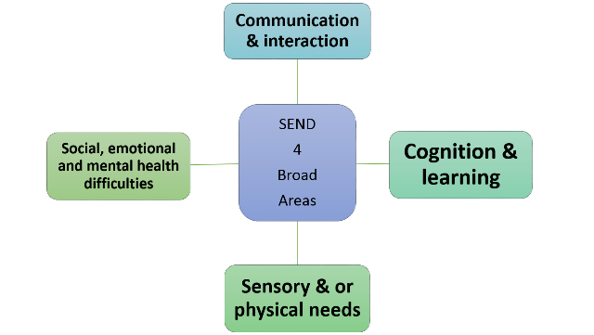
If your child has SEND, then their needs will fit into one or more of these.

Introduction

- At St Mary’s we welcome everybody into our community. The staff, governors, pupils and parents work together to make St Mary’s Primary School a happy, welcoming place where all children can achieve their highest potential and develop into resilient, courageous and independent individuals.
- We believe that equality of opportunity must be a reality for our children. We are committed to making this a reality through the attention we pay to our school family, providing a learning environment that enables all pupils to make progress and achieve their greatest potential in a caring, supportive and inclusive environment.
- Our SEND provision allows pupils with additional needs the opportunity to follow a curriculum specifically tailored to achieve personalised outcomes providing pupils self-confidence through their learning, enabling them to maximise their potential.



At St Mary’s Primary School, we aim to ensure that:

- Children with additional needs are able to access a broad, balanced and relevant curriculum as part of the whole school community.
- We identify and assess children with SEND as early and as thoroughly as possible using the revised Code of Practice (2015) and the Somerset Graduated Response Framework tools.
- Children with SEND are educated, wherever possible, in an inclusive environment alongside their peers to enable each student to reach his/or potential.
- Parents/carers and children are fully involved in the identification and assessment of SEND, and that we strive for close co-operation between all agencies concerned, using a multi-disciplinary approach.
- We meet the needs of all children with SEND by offering appropriate and flexible forms of educational provision, by the most efficient use of available resources.
- We maintain up to date knowledge of current SEND good practice and methodology in order to offer support and training in these areas to all staff in the school.
- The school building is physically accessible to all pupils and staff.



The Graduated Response in Somerset
Somerset’s Graduated Response Tool sets out the barriers to learning that children and young people may have and the strategies and provision that could be in place to support them.
Somerset’s Graduated Response Tool has been created to support all users to understand the Graduated Response to Special Educational Needs in the context of current legislation. The document makes it clear ‘what to expect’ in terms of what is provided and is written for parent carers, children and young people, school staff and those who provide services to families.
The tool sets out the provision that is ordinarily available in Somerset schools at both the Universal and Special Educational Needs (SEN) Support levels.
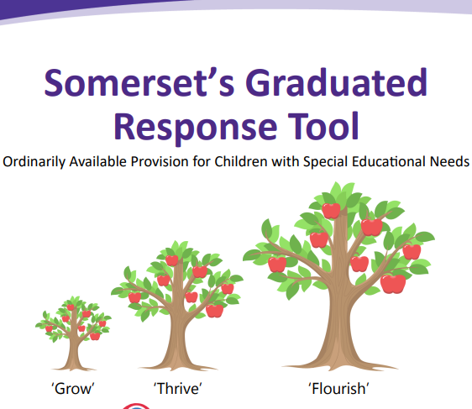
All children and young people (CYP) attending a mainstream school have an entitlement to access a minimum provision. The purpose of the Somerset response tool is to ensure every child and young person in a Somerset school receives the support they are entitled to. Most children and young people in Somerset will have their needs met within Universal support through high quality teaching. Some children and young people will require or need Special Educational Need (SEN) support at SEN Support level in addition to Universal support. The document sets out the ordinarily available provision in Somerset schools at both the Universal and SEN Support levels. To see more visit Graduated Response Tool

How will the school support my child and their learning?
- Teachers and staff will seek to identify the need of the pupils with SEND through an Assess, Plan, Do Review cycle.
- Teachers will provide universal high-quality teaching. In line with the code of practice, the majority of the pupils will have their SEND needs met in class and will have access to a broad and balanced curriculum. All teachers are committed to reducing barriers to learning for pupils with SEND, by planning work which is appropriately differentiated and includes strategies from the graduated response tool.
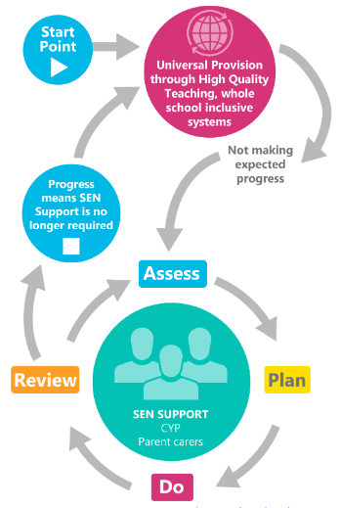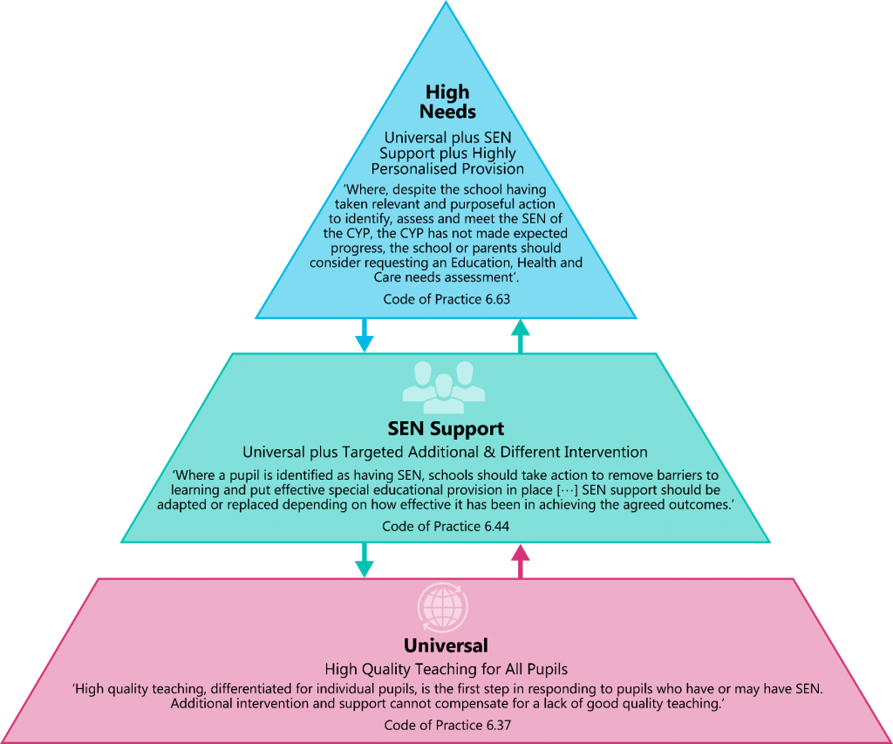
- Teachers and staff monitor the progress of all pupils. Continuous monitoring of pupils with SEND by all teachers will help to ensure that they achieve their potential.
- Work in partnership with parents/carers to gain a more informed understanding of their child and involve them in all stages of their child’s education. Parents are consulted during the writing of an Education and Health Care Plans (EHCPs), Annual reviews, SEND reviews, Early Help Assessments (EHAs) Support plans and School Entry Plans (SEP).
- Work with and seek appropriate support from outside agencies when the needs of the pupil can’t be met by the school alone, for example speech and language therapists.

What is Somerset’s Local Offer
Information on the services available for children and young people with Special Educational Needs and/or Disabilities (SEND) aged between 0 to 25 and how to access them are detailed on the Somerset Local Offer website.
The information and services available in Somerset are for all children and young people with SEND. The local authority is responsible for, whether or not they have an Education, Health and Care Plan (EHCP), to help families to make the best decisions.

SEND Local Offer
Somerset’s Local Offer is also an important resource for professionals to support understanding of the range of services and provision for children and young people with SEND across the county.

You can read more about what the Local Offer provides here: https://beta.somerset.gov.uk/education-and-families/the-local-offer/about-the-local-offer/local-offer/

Area of need | Universal  Quality First Teaching -Differentiated Strategies/Delivery  (all teachers are teachers of SEND) | Universal +/ Targeted  Broken down provision available to all if required  (Open to both SEN and non-SEN) | SEN/ Targeted Plus  Provision that is ‘additional to and different from’ | Specialist/ High needs  External support requested  Managed with the SENCo
 |  | These interventions may be used for a child on and off the SEND register. The identification process for a child with SEND barrier will be completed thoroughly and monitored.
Cognition and Learning | High quality teaching – Universal barriers record  Differentiation – task, outcome, support, resources, place or pace.  Focused objectives discussed in PPMs  Coloured overlays  Writing frames  Chunked instructions/Task chunking  Processing time  Word mats  Visual aids – widget  Concrete objects  Checklists/ lists  Pre-teaching of vocabulary  Alternative methods of recording  Seating plan fluid but considered  Regular reading  Rising Stars Gap Analysis  Additional differentiated home learning Additional individual teaching  Additional TA support | Precision Teaching  Colourful semantics  ELS/ Phonic Intervention  Individual pre-teaching concepts  Reading Intervention support  Writing Intervention support  Targeted use of I-pad/Apps  TALC assessment and guidance followed  1:1 task support  English support flow chart followed  Fred’s reading  Executive functioning top tips followed  Spelling Detectives  Individual Literacy Intervention (ILI)  Barrington Stoke books  Number Stacks | Pupil passport  Support plan SMART targets: intervention’s planned and delivered.  5-minute box  ILI – strategies  Precision teaching  Colourful Semantics – bespoke (1:1)  TEACHH approach  Spelling Detectives strategies  Individual Literacy Intervention (ILI)  Barrington Stoke books | Individual Timetable  Bespoke planning  TEACHH approach  EP Request/Support  External outreach request  EY/ SY developmental journal  Virtual School step in Nurture base  Assistive technology  EHCP
Communication and Interaction | High quality teaching – Universal barriers record  Visual timetable displayed  Modelling  Social stories  Timers  Sensory regulation resources used  Chunked instructions  Chunked learning – movement breaks  Focus breaks  Processing time  Pre-teaching of vocabulary  Now and Next  Task Board  Widget – consistent school visuals used  Exit cards  Reduced clutter  Reduced language | Individual workstation  Now and next approach  Social skills group  Social stories  SALT care plan  Speech and langauge therapist  Access to the calm corner/ sensory regulation tools | Pupil passport  Support plan SMART targets: intervention delivered.  Attention Autism  Black sheep intervention  TEACHH approach/ workstation  TalkAbout intervention  Individual social stories  Individualised visuals  Individualised now and next Dark den/ Safe space | Individual Timetable  Bespoke planning  Specialist outreach referral  Virtual School step in TEACHH approach  SALT Request/Support  Nurture base  EP Request/Support  Virtual school via the inclusion line involvement  CIAT  EHCP
Social, Emotional and Mental health | High quality teaching – Universal barriers record  Relationship policy adhered to/ethos.  My Happy Mind  Relational Approach  Meet and greet at start of day  Seating plan considered for child  Class rules/rewards followed  Zones of regulation  Positive praise/Support  Time out table to support regulation  Visual timetable displayed  Peer mentors  Parental Support Drop in sessions  Attendance Support  Lunchtime zones support unstructured times  School Responsibility (Mini police, chaplains, class responsibility)  MHST referral | ELSA  Draw and Talk  Forest School  Cooking  Lego Therapy  My Happy Mind – interventions  Regular parental contact/ contact book  Hidden chimp exercises  Executive functioning top tips/ EPIC booklet followed  Regular check ins  Boxall assessment and plan  PFSA  Dark den/ Safe space  Individual workstation  Additional PE coach  Trauma informed approach  Access to the calm corner/ sensory regulation tools | Pupil passport  Support plan SMART targets: intervention delivered.  ABCC charts/ recording  My Happy Mind – interventions  Individualised therapy ADHD Records kept | Allocation referral  Alternative curriculum  Positive Behaviour Plan  Off-site Alternative Provision  School dog  Family Intervention Service/ CSC – not SEN dependent  ADHD team support  Play therapy referral  PEEP/Risk Assessment  EHCP  Nurture base  CAMHS
Sensory and/or Physical | High quality teaching – Universal barriers record  Writing slopes  Range of pencil grips/Pencils  Finger exercises/Thera putty  Differentiated handwriting practice  Hearing/visual aids and equipment  Planned class movement breaks  Disco Dough (Foundation)  Sensory regulation resources used  Whole class track  Whole class movement  Medical Plan  Toileting plan | Learn to move intervention  Integrated therapy fact file intervention  Executive functioning top tips/ EPIC  Cushion wedge  Chair band  OT Support/Care Plan  Individual movement breaks  School nurse referral | Pupil passport  Support plan SMART targets: intervention delivered.  Sensory processing checklist completed and intervention followed  Sensory Sand Therapy  ITS Fact file targets  School nurse referral | Health Care Plan  Toileting Support  PEEP/Risk Assessment  Visual team support  SENITAS - Assistive technology  EHCP
What provision does the school offer to support my child’s needs?
Area of need | Universal  Quality First Teaching  Differentiated Strategies/Delivery  (all teachers are teachers of SEND) | Universal +  Broken down provision offered to all if required  (Open to both SEN and non SEN) | SEN  Provision that is ‘additional to and different from’ | High needs  External support requested  Managed with the SENCo
Cognition and Learning | High quality teaching – Universal barriers record  Differentiation – task, outcome, support, resources, place or pace.  Focused objectives discussed in PPMs  Coloured overlays  Writing frames  Chunked instructions  Processing time  Word mats  Visual aids  Concrete objects  Task chunking  Checklists/ lists  Pre-teaching of vocabulary  Alternative methods of recording  Seating plan fluid but considered  Daily reading  Rising Stars/WRH Gap Analysis  Additional differentiated home learning Additional individual teaching  Additional TA support | Precision Teaching  Colourful semantics  ELS/ Phonic Intervention  Spelling Detectives  Maths Intervention?  Numicon: Breaking Barriers?  Pre teaching concepts  Specialist assessment/testing  Reading Intervention support  Writing Intervention support  Targeted use of I-pad/Apps  TALC assessment and guidance followed  1:1 task support  English support flow chart followed | Pupil passport  Support plan SMART targets: intervention delivered.  Individual Literacy Intervention (ILI) | Individual Timetable  Bespoke planning  EP Request/Support  External professional request  EY developmental journal  SENITAS  EHCP
Communication and Interaction | High quality teaching – Universal barriers record  Visual timetable displayed  Modelling  Social stories  Timers  Sensory regulation resources used  Chunked instructions/ chunked learning – movement breaks  Focus breaks  Processing time  Pre-teaching of vocabulary  Now and Next  Task Board  STC – visuals used  Exit cards  Reduced clutter/ Reduced language | TalkAbout intervention  Individual workstation  Now and next approach  Social skills group  Social stories  SALT care plan  Speech and langauge therapist  Dark den/ Safe space | Pupil passport  Support plan SMART targets: intervention delivered.  Attention Autism  Black sheep intervention  TEACHH approach  Individual social stories  Individual visuals  Individualised now and next | Autism Outreach team Referral/ Support  SALT Request/Support  CAOT  CIAT  EHCP
Social, Emotional and Mental health | High quality teaching – Universal barriers record  Relationship policy adhered to/ethos.  Meet and greet at start of day  Seating plan considered for child  Class rules/rewards followed  Zones of regulation  Positive praise/Support  Time out table to support regulation  Visual timetable displayed  Peer mentors  Parental Support Drop in sessions  Attendance Support  Lunchtime zones support unstructured times  School Responsibility (Mini police, chaplains, class responsibility) | ELSA  Draw and Talk  Forest School  Cooking  Lego Therapy  Regular parental contact  Hidden chimp exercises  Contact book  Executive functioning top tips/ EPIC booklet followed  Regular check ins  Boxall assessment/ guidance  PFSA  Dark den/ Safe space  Individual workstation  Additional PE coach  Trauma informed approach | Pupil passport  Support plan SMART targets: intervention delivered.  ADHD record sheets used  Sensory Sand Therapy  Individualised therapy | Allocation referral  Alternative curriculum  Positive Behaviour Plan  Off-site Alternative Provision  School dog  MHST referral  Family Intervention Service (EHA)  ADHD team support  PEEP/Risk Assessment  EHCP  Nurture room  CAMHS
Sensory and/or Physical | High quality teaching – Universal barriers record  Writing slopes  Range of pencil grips/Pencils  Finger exercises/Theraputty  Differentiated handwriting practice  Hearing/visual aids and equipment  ADHD support resources (range)  Planned class movement breaks  Disco Dough (Foundation)  Sensory regulation resources used | Learn to move intervention  Integrated therapy fact file intervention  Executive functioning top tips/ EPIC  Cushion wedges etc  OT Support/Care Plan  Planned individual movement breaks  Medical Plan  Toileting plan | Pupil passport  Support plan SMART targets: intervention delivered.  Sensory processing intervention followed  ADHD Records kept  Sensory Sand Therapy  ITS Fact file targets | Health Care Plan  Toileting Support  PEEP/Risk Assessment  Visual team support  SENITAS  EHCP


How will a child’s progress be measured?
- As a school we measure children’s progress in learning against national age-related expectations.
- Intervention progress will be measured and monitored.
- Class teachers will continually assess each child using a range of methods.
- Children who are not making expected progress are identified through termly pupil progress meetings. In these meetings a discussion will take place about pupils experiencing difficulties and further support can be given to aid their progress.
- Children that are working well below age-related expectation or making insufficient progress will have an SEN support plan to follow. These will be shared and reviewed with the parents and children termly.
- The SENCO, SLT and class teachers monitors the effectiveness of the provision made for children with SEND through continuous assessment, classroom observations, discussions as a team with SLT members, class teachers, parents and children and the analysis of class/whole school data.


What is the pastoral, medical and social support available in the school to ensure my child’s overall well-being?
- The school/building/classroom entrances are staffed with adults who greet and welcome children and their families each morning. This ensures a smooth transition between home and school each day.
- The class teacher has overall responsibility for pastoral, medical and social care of every child in their class, therefore this is the first point of contact should you have any concerns regarding your child.
- At St Mary’s, we have an Emotional Literacy Support Assistant (ELSA), a Parent and Family Support Advisor (PFSA) and we work closely with external support including the Mental Health Schools Team, the Educational Psychology Service and the Virtual Schools Team.
- Our Emotional Literacy Support Assistant and Parent and Family Support Advisor offer a dynamic, developmental approach to working with children that helps teachers to interpret their behaviour and address their emotional needs. They also offer advice to families needing support. This can be on-going support or short term for crisis moments.
- All children attend a term of outdoor forest school throughout the year at St Mary’s Primary School. The sessions are carefully planned by a forest school coordinator.


How does the school manage the administration of medicines and personal care?
- We have a policy regarding the administration and management of medicines on the school site.
- Parents can contact the school office if medication needs to be administered during the school day and appropriate forms will be completed and signed.
- If a child’s health care needs are longer term, a medical or health plan will put in place. This will be co-produced with health care professionals, parents, the administrator and the SENCO.
- Staff receive the relevant training regarding medical conditions and medication affecting individual children. This is so that staff can manage a medical situation, should it arise.
- If a child requires personal care, a Personal Care Plan will be put in place and staff will receive appropriate training to undertake this level of care.

If your child is joining us from another school:
- The SENCO or class team will undertake a pre-visit where appropriate and will talk to the previous school staff.
- Transition social stories and photo stories to support children can be supplied if necessary.
- If your child has involvement from external professionals, then a Team Around the Child meeting or a School Entry Planning meeting will be arranged prior to them starting school.
If your Child is moving to another school:
- We will contact the SENCO of the new school and ensure that he/she knows about any special arrangements or support your child may need.
- Where possible, a planning meeting will take place with the SENCO from the new school.
- We will ensure that all records about your child are passed onto to the new school.
Year 6 transitions:
- The SENCO will discuss specific needs of your child with the new SENCO of the child’s secondary school.
- Where possible, your child will visit their new school on several occasions and in some cases staff from their existing school will attend with them.

Who can I contact for further information or to discuss a concern?
- The first point of contact would be your child’s class teacher to share your concerns.
- Visit our website for more information on Special Educational Needs.
- Meetings with the SENCO (Mrs Gemma Barnett) or the PFSA (Mrs Tracey Porter) can be arranged if staff and parents feel this is appropriate.
- For more information on the Local Authority offer please visit the link below: https://www.somerset.gov.uk/children-families-and-education/the-local-offer/
- Somerset SENDIAS is an organisation that provides independent advice and support for families:
Phone: 01823 355578 Email: info@somerset.org.uk
- Somerset Parent Carer Forum is an independent group of parents/carers who joined together to share information, their views and experiences of children’s/young person’s services (0-25 years). If you would like to find out more about this organisation then please visit: https://somersetparentcarerforum.org.uk/
Phone: 01278 699397
Useful Websites:
Hearing impairment: https://www.ndcs.org.uk/
Autism: https://www.autism.org.uk/
NHS: http://www.sompar.nhs.uk/what-we-do/children-and-young-people/parent-carer/
Vision: https://www.somersetsight.org.uk/
Young Somerset: https://www.youngsomerset.org.uk/
Our school contact: Telephone: 01278 422691 Email: office@stmarysbridgwater.co.uk

What if I have a complaint about the provision made at St Mary’s Primary School?

- Your feedback is always greatly appreciated. If you are satisfied or unsatisfied with the provision, put in place for your child at school, you are welcome to leave us a review or speak to a member of staff to provide us with your feedback.

- If you wish to discuss your child’s is progress, please contact your child’s class teacher.

- If you require further guidance, then please speak to our school SENCO, Mrs Gemma Barnett, the Head Teacher, Mrs Morwenna Dunstan, or The SEND Governor, Mrs Mary Clothier.


This report was co - produced on 10/12/24, updated on 18/07/2025, updated further on 20/07/26.

This report was co-produced with parents and governors on 29/11/2019

