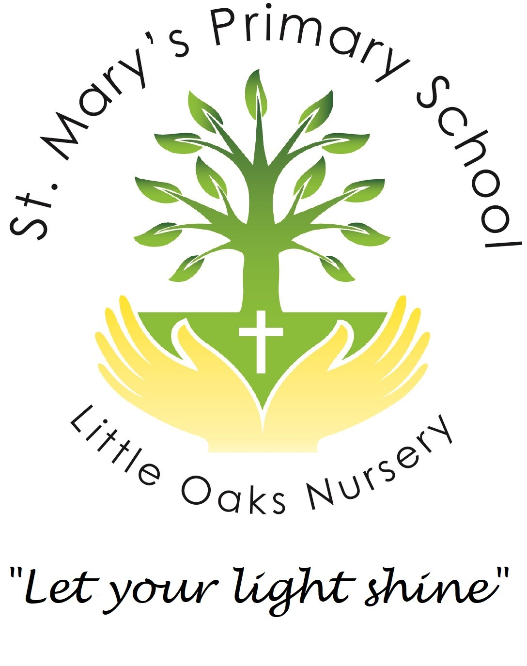

Little Oaks Nursery

St. Mary’s Primary School, Bridgwater, Somerset, TA6 7LX

01278 422691

littleoaks.nursery@stmarysbridgwater.co.uk

For all enquiries, please use our dedicated enquiries email address: enquiries@littleoaksnursery.org.uk

Registration Form

Key Information

Child’s Surname

Child’s First Name(s)

Known As

Date of Birth

Sex |  | Boy |  |  |  |  |  |  | Girl
Religion |  |  |  |  |  | Ethnicity
First Language

Any Other Language spoken

Office Use Only

Date Received:
Date Acknowledged:
Proposed Start Date:
Parent contacted to confirm start date:

Parent/Carer 1 |  | Relationship to the child
 |  | Parental Responsibility |  |  |  |  |  |  |  |  |  |  |  | Yes |  |  |  |  |  |  | No
Name
National Insurance Number
Address

 |  |  |  |  |  |  |  |  |  |  |  |  |  | Post Code
Email Address
Telephone Number |  | Home |  |  |  |  |  |  |  |  | Mobile
Place of Work
Job Title |  |  |  |  |  |  |  | Dept.
Address
 |  |  |  |  |  |  |  |  |  |  |  |  |  |  |  | Post Code
Telephone Number |  |  |  |  |  |  |  |  |  | Ext.
Able To Collect Child |  | Yes |  |  |  |  |  |  |  | No
Parent/Carer 2 |  | Relationship to the child
 |  | Parental Responsibility |  |  |  |  |  |  |  |  |  |  |  |  |  | Yes |  |  |  |  |  | No
Name
National Insurance Number
Address
 |  |  |  |  |  |  |  |  |  |  |  |  |  |  | Post Code
Email Address
Telephone Numbers |  | Home |  |  |  |  |  |  |  |  |  |  | Mobile
Place of Work
Job Title |  |  |  |  |  |  |  | Dept.
Address
 |  |  |  |  |  |  |  |  |  |  |  |  |  |  |  | Post Code
Telephone Number |  |  |  |  |  |  |  |  |  | Ext.
Able To Collect Child |  | Yes |  |  |  |  |  |  |  | No
Do any other individuals have Legal contact arrangements with this  Child? |  |  |  |  |  |  |  |  |  |  |  |  |  |  |  | Yes |  |  |  |  | No
If Yes, please provide details below and a copy of relevant documentation
Emergency Contacts Other Than Parents/Carers
 | Contact No. 1 |  |  |  |  |  | Contact No. 2
Name

Relationship To
Child
Address

Tel. No

Mobile No.

Password for
Collecting child

As security is of the utmost importance, we request that you inform the nursery of any delay or changes to collection arrangements.

Medical Details

Doctors Name:
Surgery Address:

Tel. No:
Health Visitor Name & Address:

Tel No.
Does your child have a Personal Child Health Record book (Red Book)  If yes, please bring to the induction visit. |  |  |  | Yes |  | No
Does your child suffer from any of the following?

 | Asthma | Allergies | Hay fever | Eczema | Other
YES
NO

Are there any other services involved with the child or family?
Social Worker | Yes | No | Date Involvement commenced
Name
Contact Information and Telephone Number
Speech and Language | Yes | No | Date Involvement commenced
Name
Contact Information and Telephone Number

CAHMS | Yes | No | Date Involvement commenced
Name
Contact Information and Telephone Number

Immunisations – Please Tick If Your Child Has Been Vaccinated Against the Following:

 | Yes | No |  |  |  |  | Yes |  |  | No
Diphtheria |  |  |  | Tetanus
Hib |  |  |  | Mumps
Measles |  |  |  | Rubella
Polio |  |  |  | Whooping Cough
Details Of Other Vaccinations

Has Your Child Had Any Infectious Diseases? |  |  |  |  | Yes |  |  | No
If Yes Please Give Details

Individual Requirements and Details
Has Your Child Any Food Allergies or Special Dietary Requirements? |  |  |  |  |  |  | Yes |  |  |  |  |  | No
Please Give Details

Are There Any Foods You Do Not Want Your Child to Have? |  |  |  |  | Yes |  |  |  |  |  |  |  |  | No
Please Give Details

Has Your Child Any Cultural or Religious Requirements? |  |  |  |  |  | Yes |  |  |  |  |  |  |  |  | No
Please Give Details

Any Other Details That May Be Useful

 | Consents
Medical Treatment

I hereby give consent for the staff of Little Oaks Nursery to…

 | Administer Emergency First Aid |  |  |  |  |  |  |  |  | Yes |  |  |  |  |  |  | No
 | Seek Emergency medical and dental attention including hospital treatment if it is deemed necessary |  |  |  |  |  |  |  |  | Yes |  |  |  |  |  |  | No
 | Administer medication, including Calpol, when necessary. (We will always contact parents beforehand to discuss whether the child is well enough to stay at the setting) |  |  |  |  |  |  |  |  | Yes |  |  |  |  |  |  | No
 | To apply a plaster when necessary |  |  |  |  |  |  |  |  | Yes |  |  |  |  |  | No
 | Parents are asked to apply sunscreen before the start of the nursery session. This ensures that there is no cross contamination, or the possibility of allergic reaction.  I understand that is my responsibility to provide sun cream, if my child attends for a full day session as well as a hat and appropriate clothing during the summer months. |  |  |  |  |  |  |  |  | Yes |  |  |  |  |  | No
 | - Please read the attached guidance sheet on infection control in schools and other childcare settings. This shows the recommended period for children to be kept away from the nursery setting for various infections and illnesses.
 | Signature…………………………………………………. Date …………………………………………
Information Technology

I hereby give consent for the staff of Little Oaks Nursery to…

 | To allow our child access to the nursery’s IT equipment, with supervision from nursery practitioners, to access age related programmes and internet sites. |  |  |  |  |  |  |  |  | Yes |  |  |  |  |  |  |  | No
 | Signature…………………………………………………. Date …………………………………………
Outings

I hereby give consent for the staff of Little Oaks Nursery to …

 | To take my child on local visits and outings |  |  |  |  |  |  |  |  |  | Yes |  |  |  |  |  |  | No
 | To travel on public transport |  |  |  |  |  |  |  |  |  | Yes |  |  |  |  |  |  | No
 | Signature…………………………………………………. Date ………………………………………
Photographs

I hereby give consent for the staff of Little Oaks Nursery to …
 | Photograph my child and for those photographs to be used in my child’s file and displays around the nursery |  |  |  |  |  |  |  |  |  | Yes |  |  |  |  |  |  | No
 | Use photographs of my child taken at St. Mary’s Nursery in another child’s file or diary (as a group) |  |  |  |  |  |  |  |  |  | Yes |  |  |  |  |  |  | No
 | Use photographs of my child in newsletters |  |  |  |  |  |  |  |  |  | Yes |  |  |  |  |  |  | No
 | Use photographs of my child on the nursery website or Facebook page  *Please note that our Facebook page is a public page, meaning that anyone on or off Facebook can search for and view the pages posts. |  |  |  |  |  |  |  |  |  | Yes |  |  |  |  |  |  | No
 | Use photographs of my child for advertising purposes |  |  |  |  |  |  |  |  |  | Yes |  |  |  |  |  |  | No
 | Signature…………………………………………………. Date …………………………………………
Sharing information

I hereby give consent for the staff of Little Oaks Nursery to …
 |  | Share information about my child with other agencies such as :  Speech and Language, Health Visitors, Special Educational Need Support |  |  |  |  |  |  |  |  |  | Yes |  |  |  |  |  |  | No
Signature................................................................ Date...................................................................

Please note staff will share information without consent if they are concerned about the welfare of the child

Name of Person Signing:……………………………………………………………………………….

Signature:…………………………………………………… Date:…………………………………….

Please indicate the sessions you would like your child to attend, the preferred days and whether you are entitled to Early Years Funding. Please note, you can mix sessions from any option.

Option 1: Choose from 1 to 5 days
Monday | Tuesday | Wednesday | Thursday | Friday
8.00am – 5.30pm | 8.00am – 5.30pm | 8.00am – 5.30pm | 8.00am – 5.30pm | 8.00am – 5.30pm
All Year Round – 48 weeks | All Year Round – 48 weeks | All Year Round – 48 weeks | All Year Round – 48 weeks | All Year Round – 48 weeks
Term Time only – 39 weeks | Term Time only – 39 weeks | Term Time only – 39 weeks | Term Time only – 39 weeks | Term Time only – 39 weeks

Option 2: Choose from 1 to 5 days
Monday | Tuesday | Wednesday | Thursday | Friday
8.30am – 3.30pm | 8.30am – 3.30pm | 8.30am – 3.30pm | 8.30am – 3.30pm | 8.30am – 3.30pm
All Year Round – 48 weeks | All Year Round – 48 weeks | All Year Round – 48 weeks | All Year Round – 48 weeks | All Year Round – 48 weeks
Term Time only – 39 weeks | Term Time only – 39 weeks | Term Time only – 39 weeks | Term Time only – 39 weeks | Term Time only – 39 weeks

Option 3: Choose from 1 to 5 mornings
Monday | Tuesday | Wednesday | Thursday | Friday
8.00am – 1.00pm | 8.00am – 1.00pm | 8.00am – 1.00pm | 8.00am – 1.00pm | 8.00am – 1.00pm
All Year Round – 48 weeks | All Year Round – 48 weeks | All Year Round – 48 weeks | All Year Round – 48 weeks | All Year Round – 48 weeks
Term Time only – 39 weeks | Term Time only – 39 weeks | Term Time only – 39 weeks | Term Time only – 39 weeks | Term Time only – 39 weeks

Option 4: Choose from 1 to 5 afternoons
Monday | Tuesday | Wednesday | Thursday | Friday
1.00pm – 5.30pm | 1.00pm – 5.30pm | 1.00pm – 5.30pm | 1.00pm – 5.30pm | 1.00pm – 5.30pm
All Year Round – 48 weeks | All Year Round – 48 weeks | All Year Round – 48 weeks | All Year Round – 48 weeks | All Year Round – 48 weeks
Term Time only – 39 weeks | Term Time only – 39 weeks | Term Time only – 39 weeks | Term Time only – 39 weeks | Term Time only – 39 weeks

Early Years Entitlement

3-Year-Old  Universal 15 hrs per week | 3-Year-Old  Extended 15 hrs per week | 3-Year-Old  Non-funded hrs | 2-Year-Old  Funding - 15 hrs per week | 2-Year-Old  Non-Funded hrs
St. Mary’s Nursery

Terms and Conditions

Sessions:

We offer the choice of All Year Round OR Term Time Sessions

Full Day Session = 8.00am – 5.30pm
School Day session = 8.30am – 3.30pm
Morning Session = 8.00am - 1.00pm
Afternoon Session = 1.00pm – 5.30pm

All session requirements must be confirmed in writing.
A minimum of 4 weeks’ notice for all session changes must be given.

Fee Payment:

Invoices will be sent out at the end of each month (in arrears) and payment is required within 7 working days. Payment by BACS is our preferred method. Bank details are provided on your invoice.

A £10 administration fee may be charged on a weekly basis for all late payments.

Holidays:

The nursery will be closed for two weeks at Christmas and for the last two weeks of August. We may also close for necessary whole school staff training. This will be for a maximum of two days in any year. A minimum of two months’ notice will be given to parents should this need to happen. The nursery will also be closed for all Bank Holidays - normal charges apply to bank holidays.

Sickness/ Absence:

Children who have, or develop, an infectious illness must be excluded from nursery for a minimum of 48 hours. This is in the best interest of the child and the other children and complies with regulations set out by the Environmental Health Department. The nursery must be notified of all absences. A copy of Spotty Book – Notes on Infectious Diseases in Schools and Nurseries will soon be available on the school/nursery website.

Sickness or absence from Nursery does not qualify for a reduction in fees.

Notice:

A calendar month’s written notice, by either party is required to terminate a child’s place at nursery. One month’s fees in lieu of notice will be charged.

Fees are still payable for the one months’ notice even if the child does not attend the nursery.

Clothing and Personal Items:

The Nursery cannot accept responsibility for loss or damage to personal items or clothing.

A nursery uniform is available to purchase.

Parents should supply sufficient clothing for their child‘s daily needs and a spare set of clothing in case of accidents. Please ensure all items are named.
Sun cream and sunhats should be supplied in the warmer months. Suitable footwear and clothing for outdoors must also be provided.

Car Parking:

There are no designated parking bays for dropping off and collecting children. Under no circumstances should any car be left parked in an unsuitable manner that could cause danger to children or to the public.

AGREEMENT

I agree to comply with the terms and conditions set out by St. Mary’s Primary School and Little Oaks Nursery

Signed…………………………………………………………Date………………….......

Name……………………………………………………………………………………......

NURSERY COPY

Useful Information for Starting Nursery

Child’s Name: D.O.B:

We ask for the following information to help us get to know your child:

- Do they have a sleep during the day; if so, for how long?

- Do they have a comforter? If yes, what is it?

- If they get upset, what advice do you offer to get them settled?

- Do they drink out of a beaker or a cup?

- Is your child able to feed him/her self?

- What foods does your child like to eat?

- Does your child wear nappies? If so, what size?

- Are you happy for us to apply nappy cream if necessary?

- If your child is toilet trained, how do they let you know if they need the toilet?

- Any other relevant information?

Thank you for sharing this information with us to help us get to know your child.

All about Me

My Name:

What I like to be called:
My Name:

What I like to be called:

My favourite thing is:

When I am sad I like:
The people in my family are:

My favourite person is:

Things I like:

Things I don’t like:
Foods I like:

Foods I don’t like:

When a child is settling, it is very useful to the nursery practitioners to have information that may be helpful in settling your child.

