Numbers for support
SAMARITANS 116 123
CHILDLNE 0800 11 11
SOMERSET MINDLINE 01823 2756892 -CHARITY SUPPORTING MENTAL HEALTH
SHOUT (TEXT SUPPORT) TEXT 85258- SUPPORT FOR THOSE FEELING OVERWHELMED
CHAT HEALTH 07480 635515 - TEXT FOR PARENTING ADVICE AND SUPPORT

WEBSITES WITH INFORMATION
ANNA FREUD
PLACE2BE
CYP SOMERSET
NSPCC

What is anxiety
Anxiety can present itself in many different ways. Your child may have difficulty sleeping, have a reduced appetite or over eat, be unusually clingy or angry and complain of headaches and stomach aches. These signs obviously may have other causes so, if they persist, speaking to you GP would be recommended.

Anything can trigger anxiety, it may be a fear of the dark, being left by their carer, a worry that there are monsters under the bed or nerves over a spelling test. Over time you will begin to know some of your child’s triggers and be prepared for them, others will come as a complete surprise.

Take a look at the anxiety curve below to help you understand the process that this emotion may take.

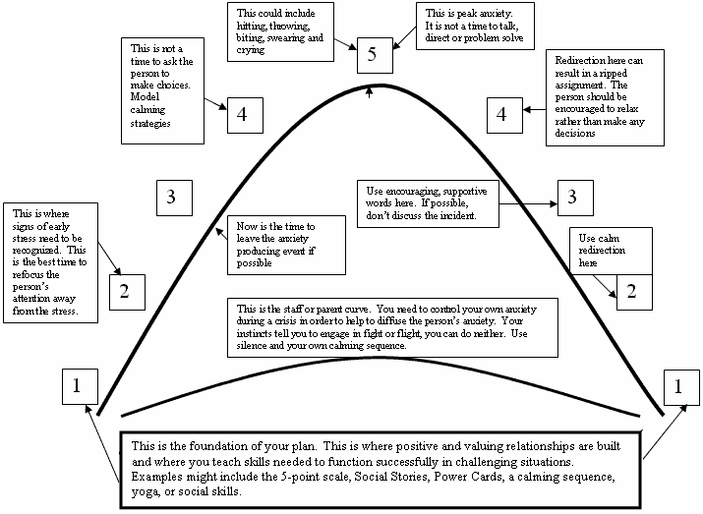
www.5pointscale.com/pinterest
None of the above is pleasant for anyone, its leaves both you and your child feeling exhausted. Often you may wonder how it got to ‘this stage.’

You can also help them by exploring that thoughts are just thoughts and not facts and model positive self-talk e.g. ‘I did a really good job tidying my room today.’
Have a look at the process below

BEHAVIOUR

FEELING

THOUGHT

QUIET AND CLINGY
STOMACH ACHE, FEELING SICK
THERE IS SOMETHING BAD IN THAT DARK ROOM

Ways to support your child.
- Be curious, notice the feeling or discomfort, wonder with them what could be causing the uncomfortable feeling.
- Listen to them.
- Help them to feel understood, normalise and validate the feeling. ‘I can see that worries you.’ ‘That must be so difficult for you, feeling like that.’
- Praise them for talking to you.
- Don’t try to solve the problem.
- Practice some relaxation, grounding exercises to use during these heightened times.

Websites

- https://www.annafreud.org/schools-and-colleges/resources/advice-for-parents-and-carers-talking-mental-health-with-young-people-at-primary-school/
- https://www.acamh.org/blog/in-conversation-anxiety

Wider reading.

- Helping Your Child With Fears and Worries by Cathy Creswell and Lucy Willetts
- The Anxiety Survival Guide for Teens by Jennifer Shannon.

Books for children

- Hidden Chimp by Prof Steve Peters
- Starving the anxiety Gremlin by Kate Collins Donnelly
- A Huge Bag of worries By Virginia Ironside

BEREAVEMENT and LOSS

At Mary’s we realise that Bereavement and loss can have a huge impact on our pupils and their families.
Some of our staff have received training to support our pupils during this very difficult time.
The following information may help you to support you and your family.

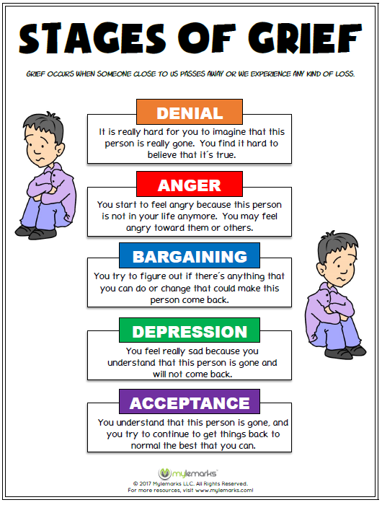

Types of loss
There are many ways in which we can experience loss.
- Death of a parent/care giver/family member/sibling or friend
- Separation of parents.
- Death of a pet.
- Moving house/school/country
- Loss of a favourite toy or object
- Parents working away
- A parent/carer going to prison
- Independence
- Ability to go outside.

In order to support your child it is useful to look at the following website about your child’s developmental stages of understanding.
https://www.cruse.org.uk/get-help/for-parents/childrens-understanding-of-death
How do I support my child?

There are many ways to do this.
- Listen, make sure that you give them time to talk.
- Use clear language when talking to them.
- Give them appropriate information.
- Read stories to them such as:
The Invisible String
Badgers Parting Gifts
Always and Forever.
Michael Rosen’s Sad Book.
Goodbye Mog.
Muddles, Puddles and Sunshine (an activity book.)

The following website has some amazing ideas to help you. Look for the small book of big conversations.
https://www.rowanshospice.co.uk/care/meerkats/
If you would like to talk to someone, please ask your child’s class teacher or staff in the office for someone to call you.

